# Deploy a war file on docker container using jenkins:

Copy artifact from Jenkins to docker target

Job -> configure -> source code management

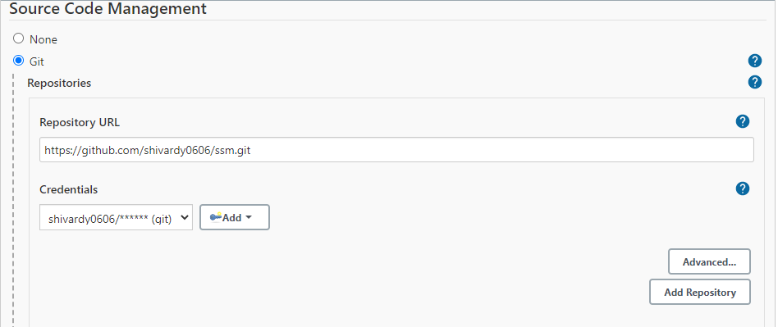

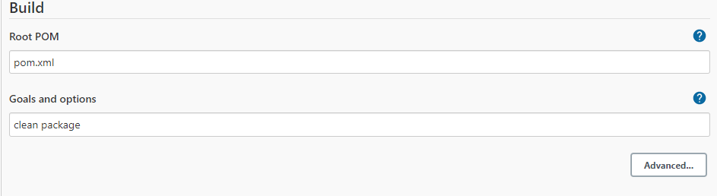

/var/lib/jenkins/workspace/maven/target

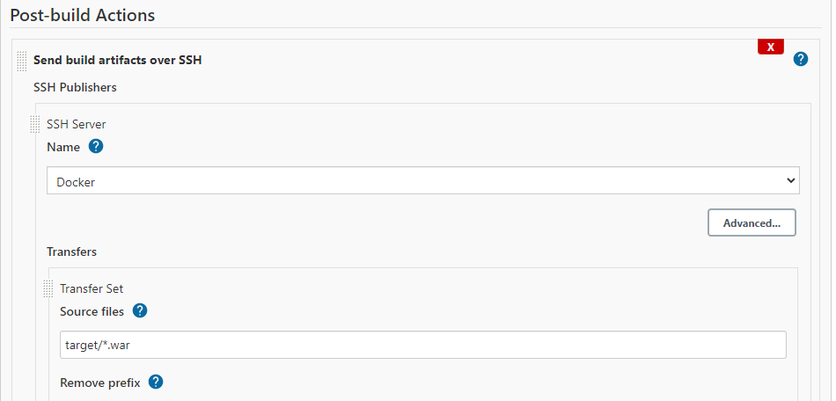

Docker ecec –ti docker_name /bin/bash

cp -R * ../webapps

# Errors

ERROR: Exception when publishing, exception message [Exec exit status not zero. Status [127]] Build step 'Send build artifacts over SSH' changed build result to UNSTABLE

Sol: system docker start (slave machine), sa me users in both master and slave.

# Integrate ansible with Jenkins:

* Create a job using maven.

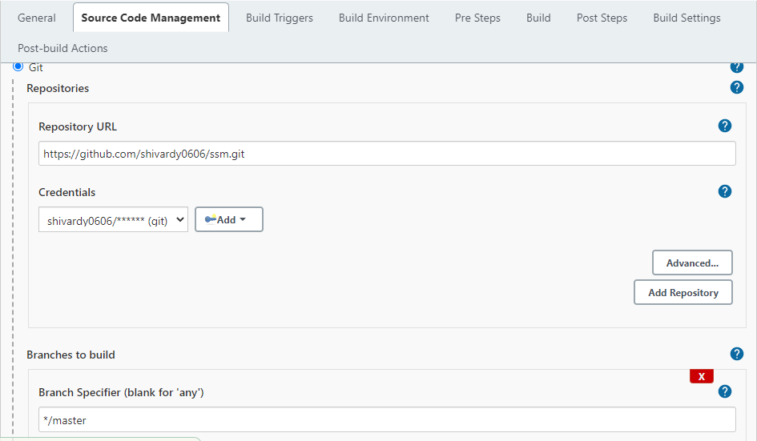

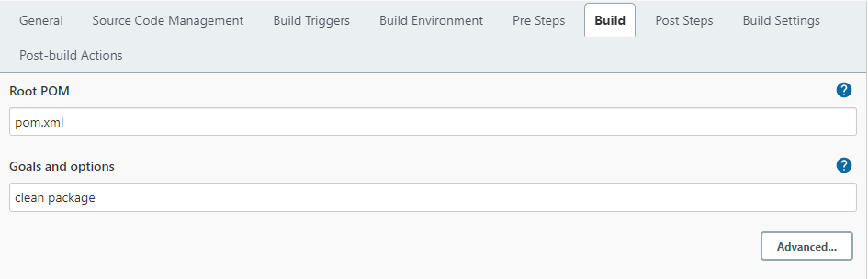

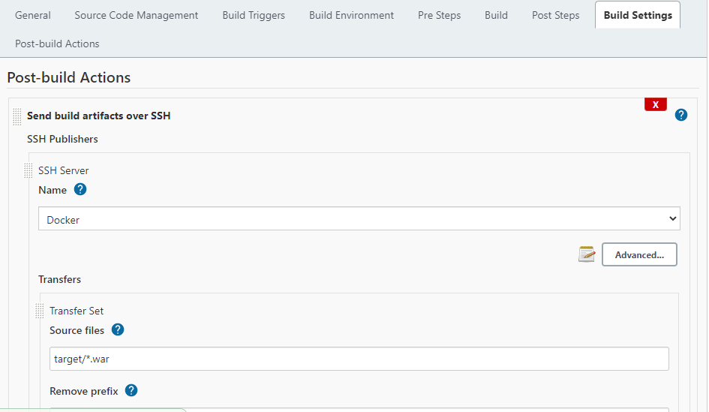

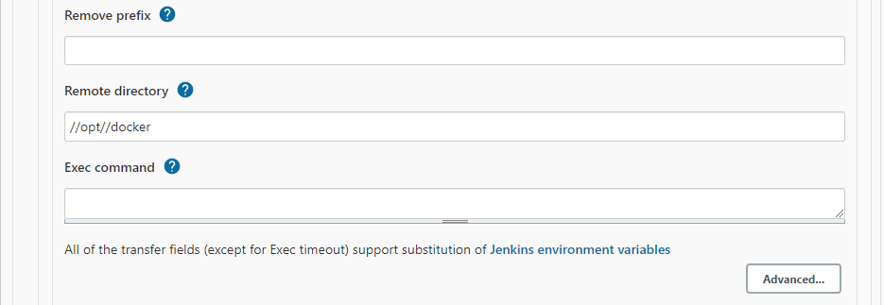

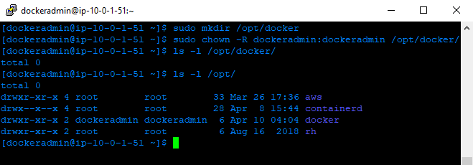

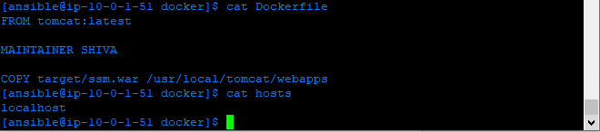

* Ssh-keygen
* Ssh-copy-id localhost
* Ssh –I hosts –m ping

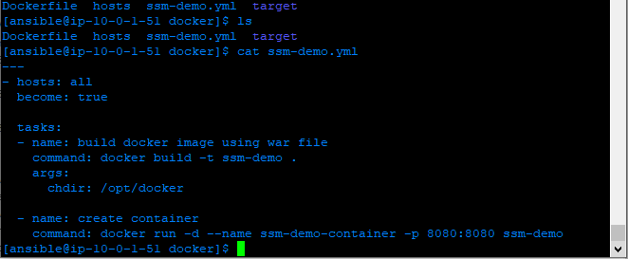

# Errors:

# There is insufficient memory for the Java Runtime Environment to continue.

# Native memory allocation (mmap) failed to map 65536 bytes for committing reserved memory.

# An error report file with more information is saved as:

# /var/lib/jenkins/workspace/Delopy_on_DC/hs_err_pid3038.log

#

# Compiler replay data is saved as:

# /var/lib/jenkins/workspace/Delopy_on_DC/replay_pid3038.log

ERROR: Maven JVM terminated unexpectedly with exit code 1

Finished: FAILURE

This is a very old question yet I just ran into this weird issue and this costed me 3 hours in debugging the Jenkins Job configurations and Jenkins plugins. This answer is to help others if they encounter the same.

Root cause: I got to know that one of a developer in my team has used system.exit(0); in his java code so actual problem was in code not with jenkins job.